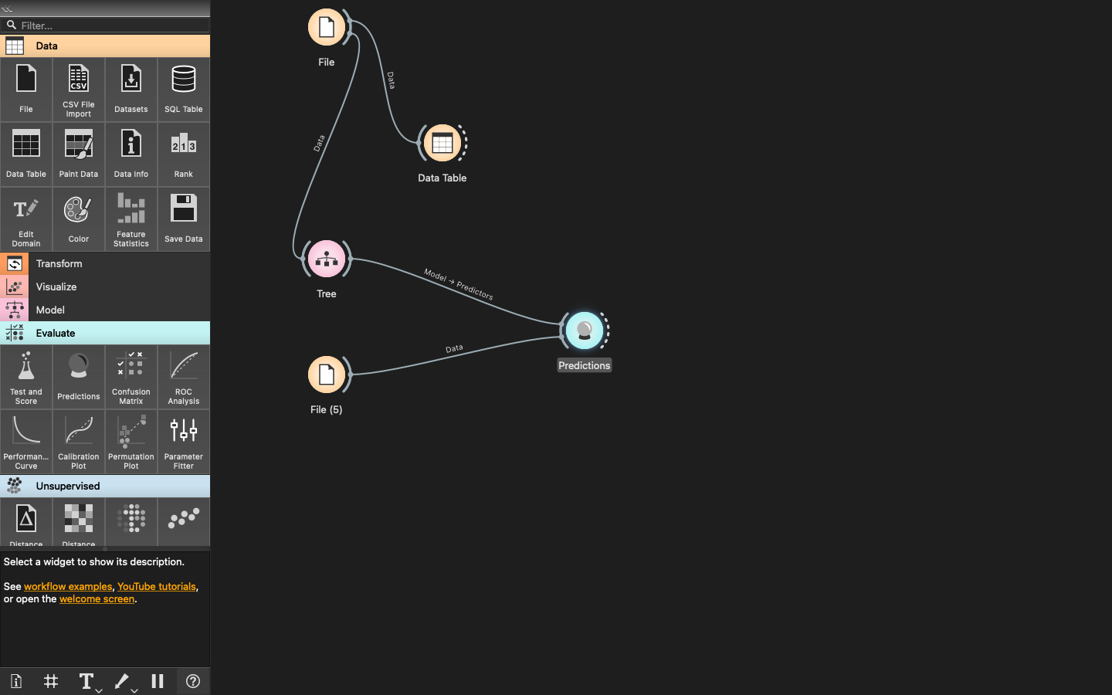

IRIS FLOWER CLASSIFICATION:

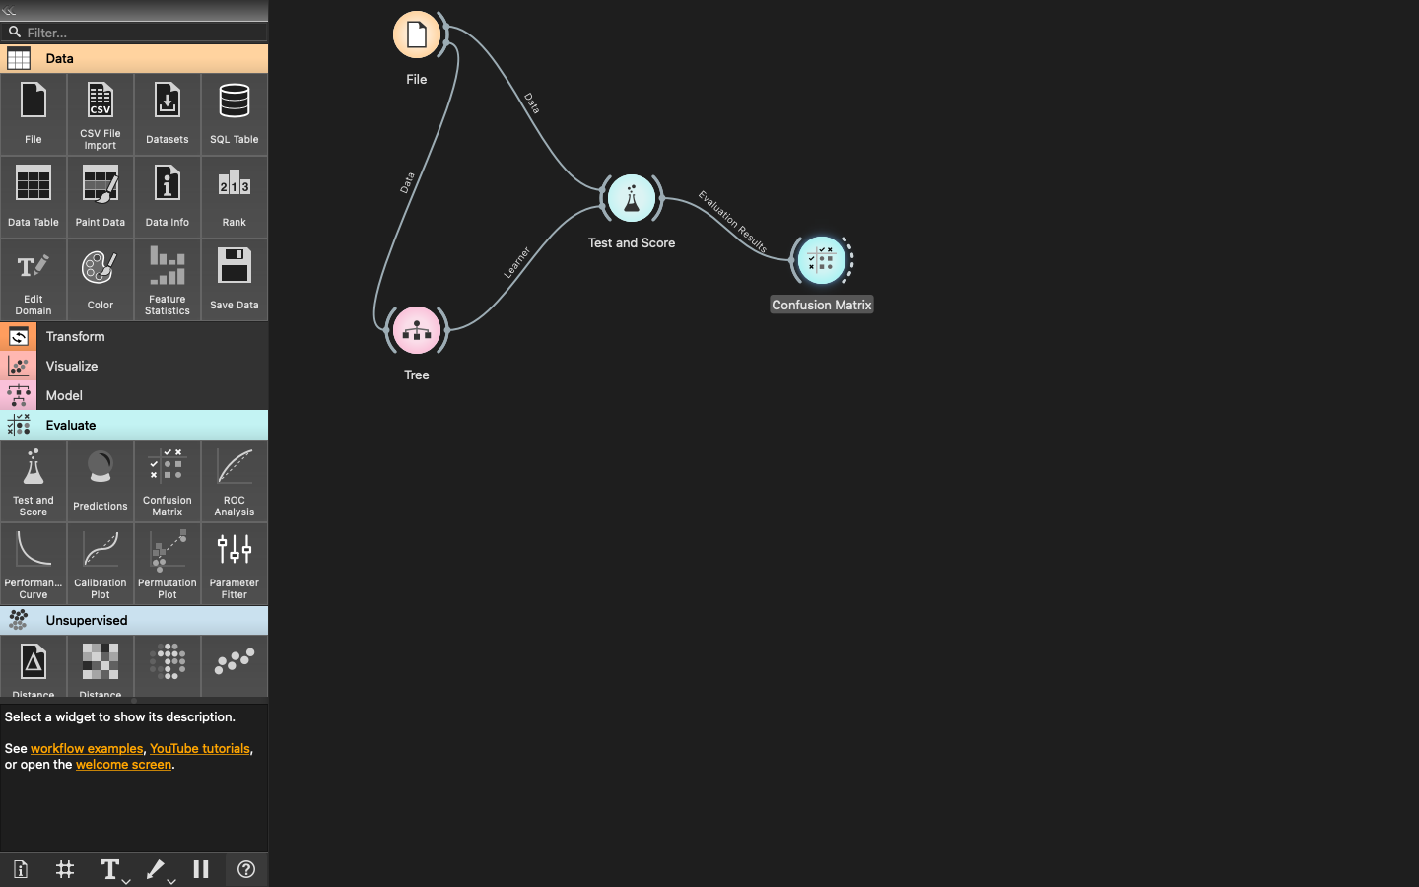**EVALUATION OF IRIS FLOWER:**

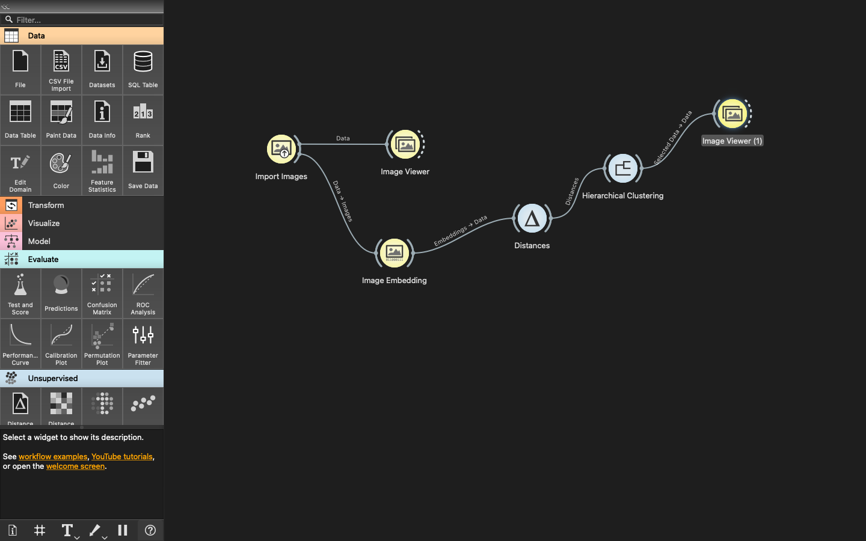

COMPUTER VISION:

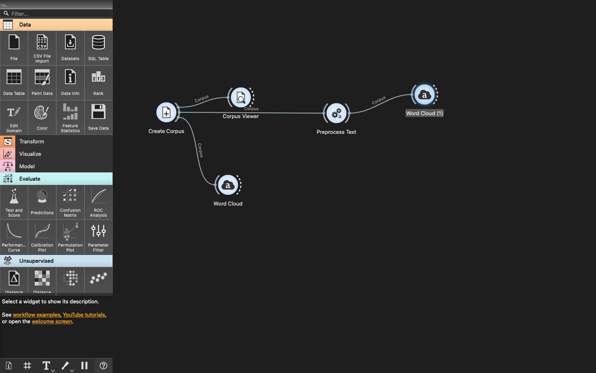

NATURAL LANGUAGE PROCESSING:

OUTPUT

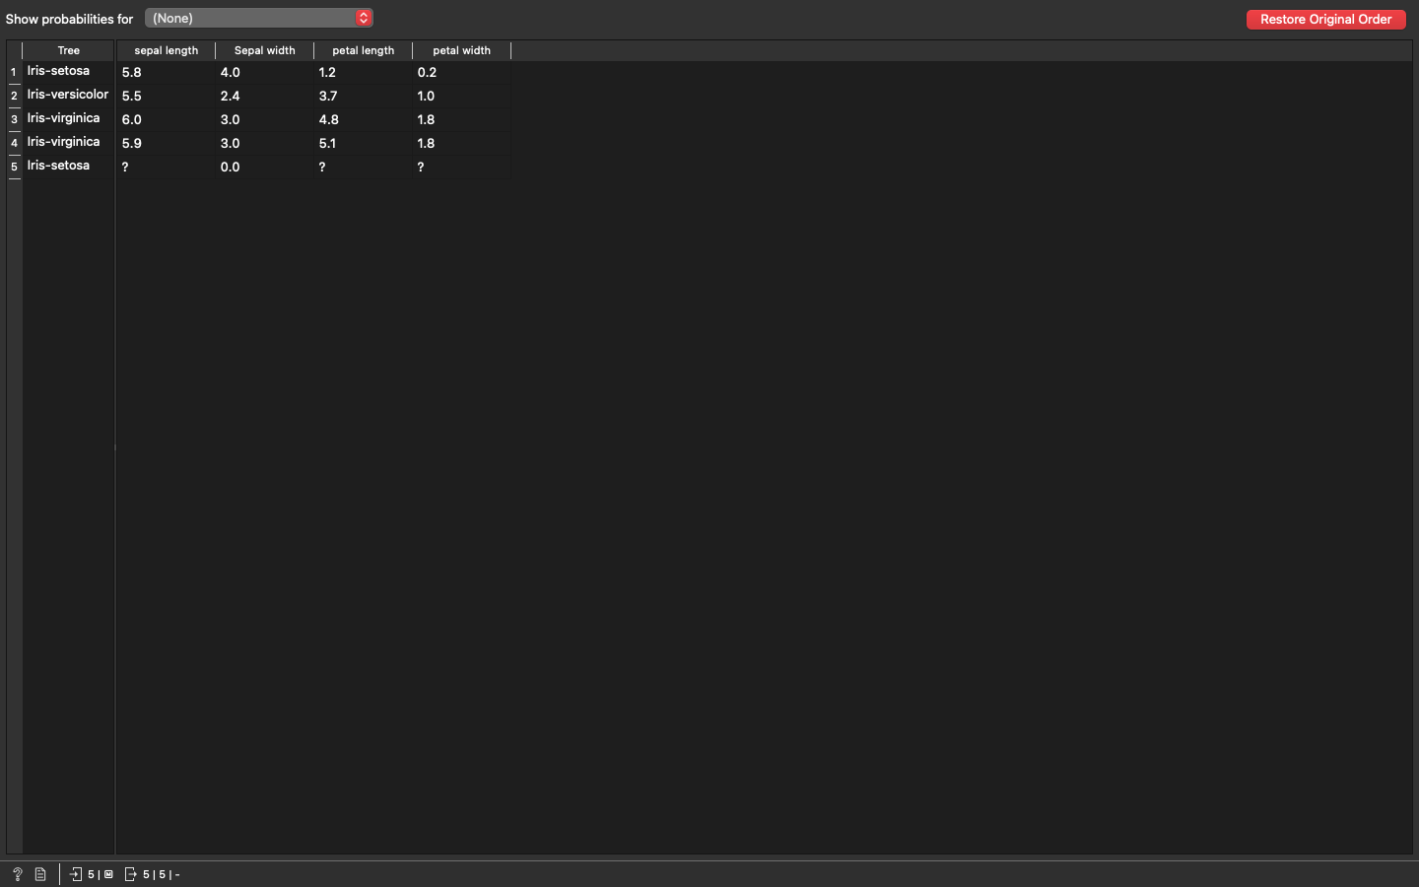

IRIS FLOWER CLASSIFICATION:

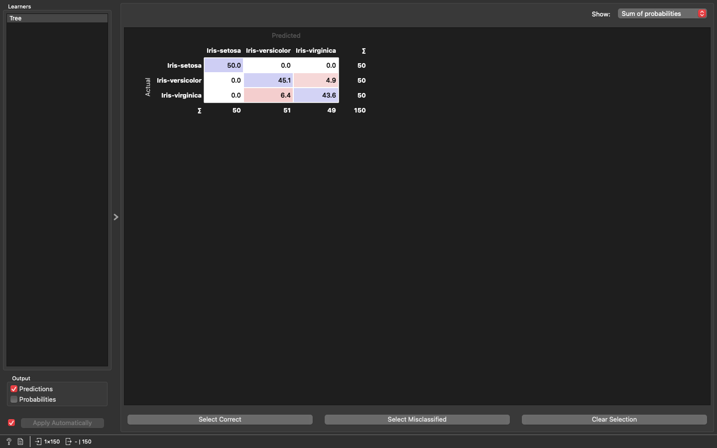

EVALUATION

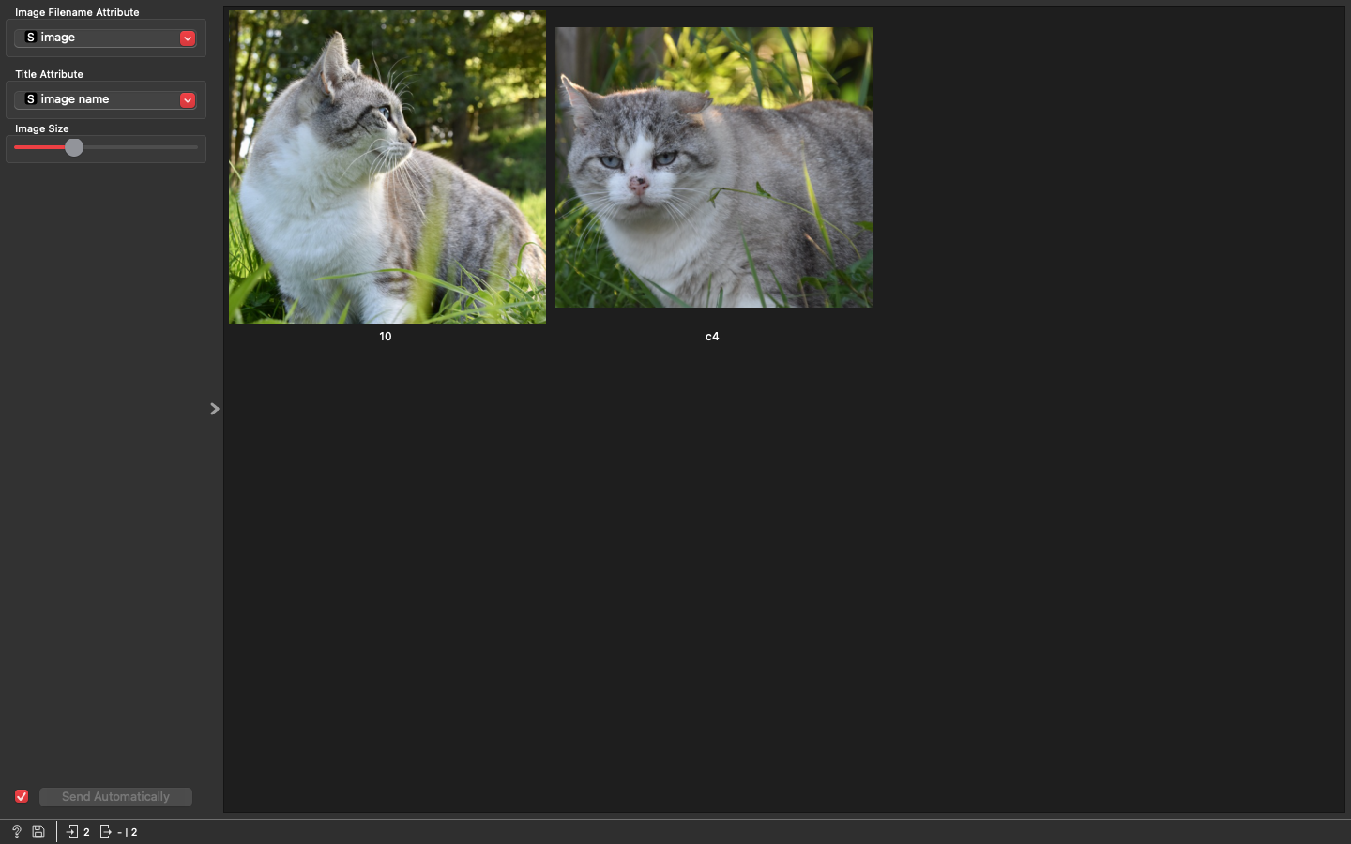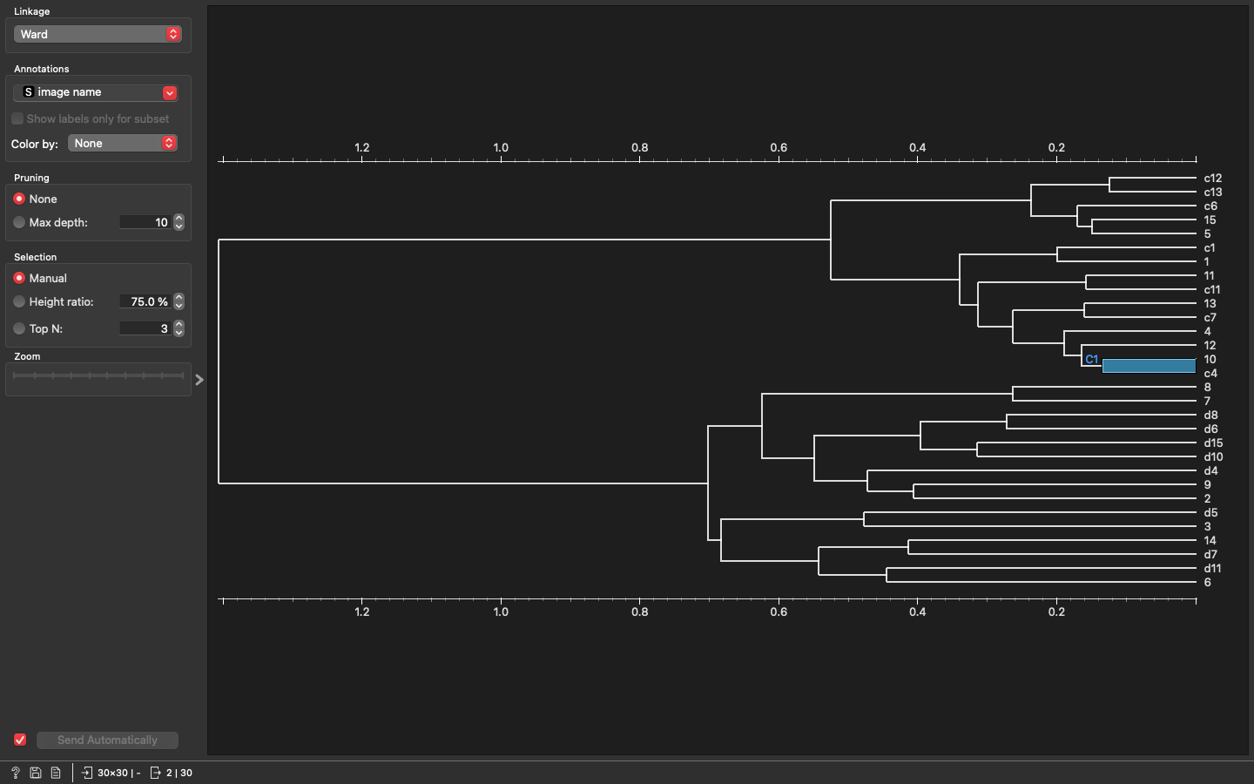

COMPUTER VISION :

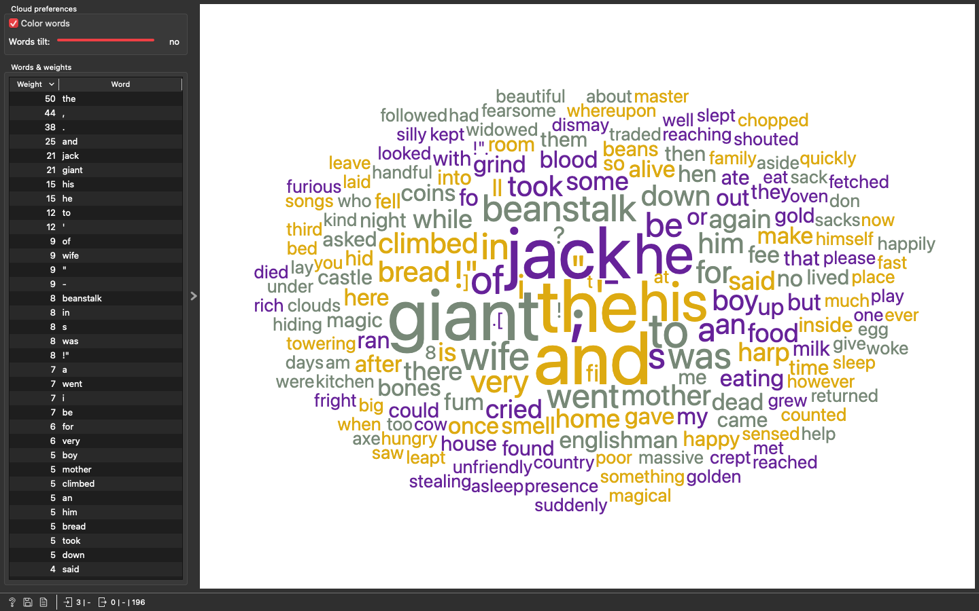

BEFORE:

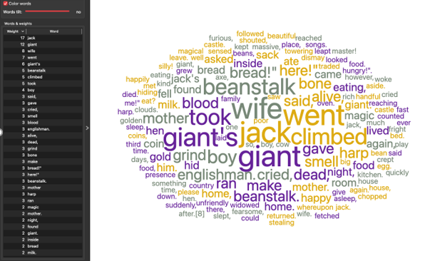

AFTER:  
NATURAL LANGUAGE PROCESSING :